Name: Varia Neel Jitesh
Enrollment No: 250447003019

Network Security And Forensics
Lab Session – 9
Study various Hash algorithms and identify various platform where they are using.
A hash algorithm is a one-way cryptographic function that transforms input data (of any size) into a fixed-length output called a hash value or digest. Hashing is fundamental in cybersecurity, networking, digital forensics, and blockchain systems.
Unlike encryption, hashing is irreversible, meaning original data cannot be retrieved from the hash.
Applications:
- Password storage
- Data integrity verification
- Digital signatures
- Blockchain systems
- File fingerprinting

Properties of Cryptographic Hash Functions
- Deterministic Nature
- Pre-image Resistance
- Collision Resistance
- Fixed Output Length
Types of Hashes
- MD5
- SHA-1
- SHA-2 Family
- SHA-3
- Bcrypt
- Scrypt
- Argon2

MD5 (Message Digest Algorithm 5)
It takes the message as input of any length and changes it into a fixed-length message of 16 bytes. MD5 algorithm stands for the Message-Digest algorithm.

MD5 was developed in 1991 by Ronald Rivest as an improvement of MD4, with advanced security purposes. The output of MD5 (Digest size) is always 128 bits.

MD5 is still the most commonly used message digest for non-cryptographic functions, such as used as a checksum to verify data integrity, compressing large files into smaller ones securely, etc.
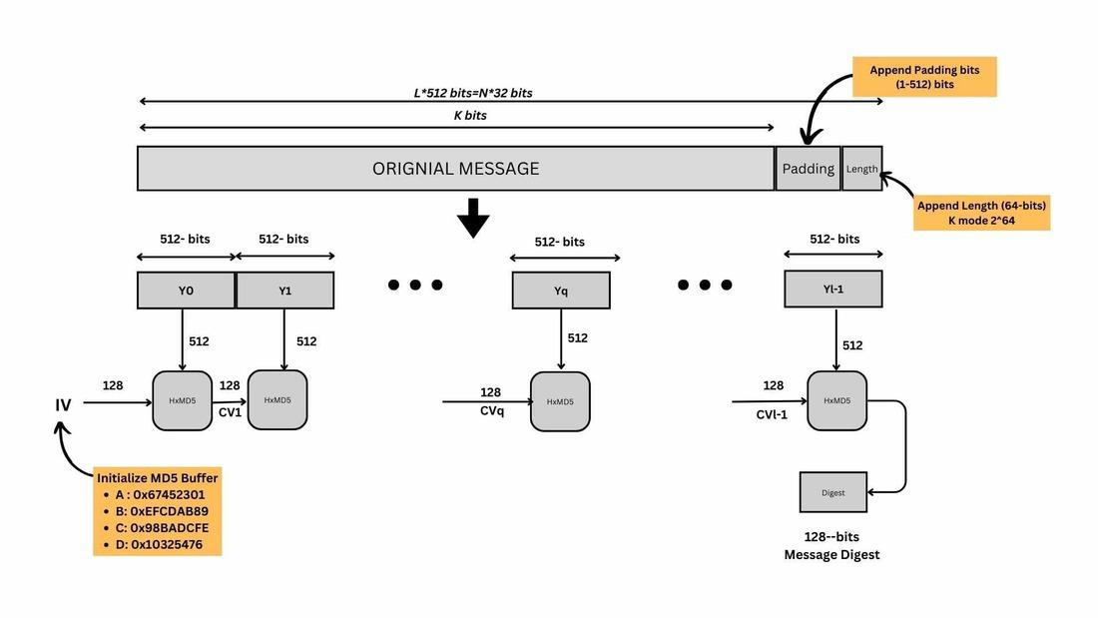

Advantages
- MD5 is faster and simple to understand.
- MD5 algorithm generates a strong password in 16 bytes format. All developers like web developers, etc. use the MD5 algorithm to secure the password of users.
- To integrate the MD5 algorithm, relatively low memory is necessary.

Disadvantages
- MD5 generates the same hash function for different inputs (hash collision).
- MD5 provides poor security over SHA1, SHA256 and other modern cryptographic algorithms.
- MD5 has been considered an insecure algorithm. So now we are using SHA256 instead of MD5.
Platforms:
- Legacy systems in Apache HTTP Server
- File verification tools (md5sum)

Use Case:
- Checking file integrity (non-secure environments)

SHA-1 (Secure Hash Algorithm 1)
SHA-1 or Secure Hash Algorithm 1 is a cryptographic algorithm that takes an input and produces a 160-bit (20-byte) hash value. This hash value is known as a message digest. This message digest is usually then rendered as a hexadecimal number which is 40 digits long. It is a U.S. Federal Information Processing Standard and was designed by the United States National Security Agency. SHA-1 is been considered insecure since 2005.
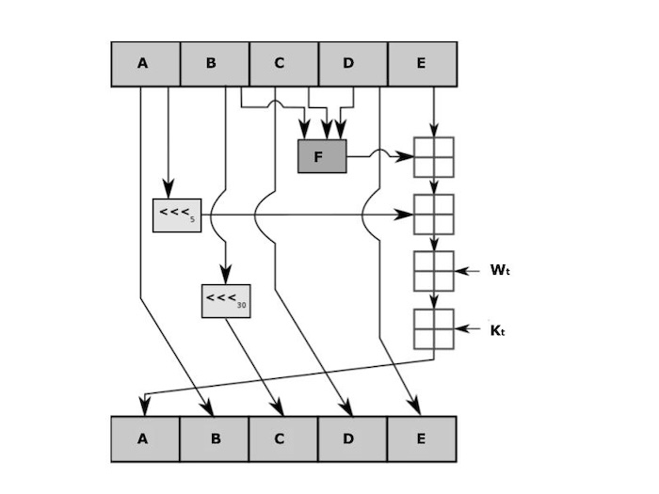

Weakness:
- Collision attack demonstrated in 2017 (SHAttered attack)

Platforms:
- Git (commit IDs, transitioning away)
- Old SSL certificates

SHA-2 Family (Secure Hash Algorithm 2) & SHA-3

Feature | SHA-256 | SHA-3
Algorithm | SHA-256 is a member of the SHA-256 family. | SHA-3 is a different hash function.
Design Process | Developed by the National Security Agency (NSA) | Designed by the Keccak Team through an open competition organised by the NIST.
Security | No known vulnerabilities as of current date. | No known vulnerabilities as of current date.
Block size | 512 bits | Variable, with the most common being the 1600 bits.
Output size | 256 bits | Variable, with standard output size being 224, 256, 384 or even 512 bits.
Performance | Generally faster due to the simpler structure. | Generally slower due to its more complex construction.
Resistance | Susceptible to length extension attacks. | Resistant to length extension attacks.
Padding scheme | Uses the Merkle Damgard construction. | Uses the sponge construction.
Message schedule | Different from SHA-3. | Based on the Keccak's permutation.

bcrypt vs scrypt

Aspect | bcrypt | scrypt
Computational Approach | bcrypt is a CPU-intensive algorithm that increases security by repeating hashing rounds, making brute-force attacks slower. | scrypt is both CPU and memory-intensive, requiring large memory along with computation, which significantly increases attack cost.
Underlying Design | bcrypt is based on the Blowfish cipher and uses an expensive key setup phase (EksBlowfish) to strengthen hashing. | scrypt is based on PBKDF combined with a memory-mixing function (ROMix), ensuring both computation and memory usage.
Resource Utilization | bcrypt mainly consumes CPU resources and uses very little memory, making it suitable for systems with limited RAM. | scrypt consumes both CPU and large amounts of RAM, making it resource-heavy but more secure against hardware attacks.
Resistance to GPU/ASIC Attacks | bcrypt provides moderate resistance, but GPUs can still speed up attacks due to parallel processing capability. | scrypt provides strong resistance because its high memory requirement limits efficient parallelization on GPUs and ASICs.
Configuration Parameters | bcrypt uses a single cost factor that determines the number of hashing iterations, making it simple to configure. | scrypt uses multiple parameters (N, r, p), allowing fine control over CPU, memory, and parallelization, but increasing complexity.
Performance and Speed | bcrypt is relatively faster and predictable in performance, depending on the cost factor used. | scrypt is slower due to heavy memory operations, and performance depends on both CPU and memory settings.
Security Strength | bcrypt is secure and widely trusted, but slightly less resistant to modern hardware-based attacks. | scrypt is more secure in modern contexts due to its memory-hard design, making large-scale attacks more difficult.
Real-World Usage | bcrypt is commonly used in web applications and platforms like Instagram and Twitter. | scrypt is widely used in high-security systems and cryptocurrencies like Litecoin.
Practical Implementation | bcrypt is easier to implement, requires fewer resources, and is supported by most frameworks, making it ideal for general applications. | scrypt is more complex to implement and requires higher system resources, making it suitable for specialized or high-security environments.

Implement a basic digital signature system using a hash function and asymmetric cryptography (e.g., RSA).

In this system:
- The message is hashed using SHA-512 (stronger than SHA-256)
- The hash is signed using the RSA private key
- The signature is verified using the RSA public key

Will do with the Python
Install this dependency
pip install cryptography

Code:
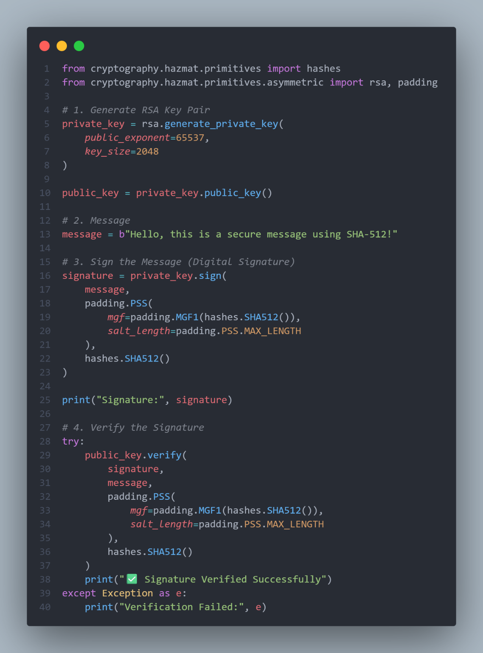
Output:
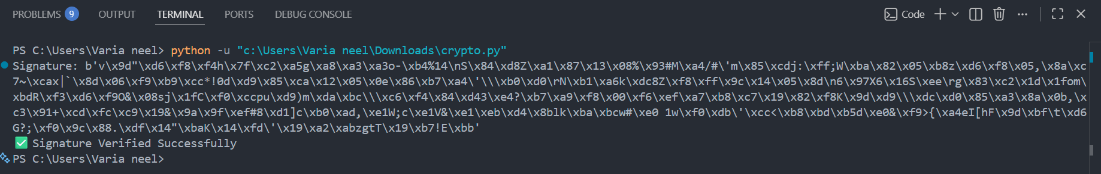

Working Flow:
Step 1: Message → hashed using SHA-512
Step 2: Hash → encrypted with private key → Signature
Step 3: Receiver:
- Decrypts signature using public key
- Recomputes SHA-512 hash
- Compares both

Real-World Usage
- SSL/TLS certificates (modern HTTPS)
- Secure APIs and authentication
- Blockchain systems
- Software signing (e.g., systems used by Google and Microsoft)

Conclusion:
Using SHA-512 with RSA enhances the strength of digital signatures by providing a larger hash size and improved resistance against collision attacks. This combination is suitable for high-security applications and future-proof systems.

Sign a message with a private key and verify the signature using the corresponding public key.

Concept
- Signing:
Message → Hash (SHA-512) → Encrypted with Private Key
- Verification:
Signature → Decrypted with Public Key → Compare with new hash
✔ Ensures:
- Authentication
- Integrity
- Non-repudiation

Will do with the Python
Install this dependency
pip install cryptography

Code:
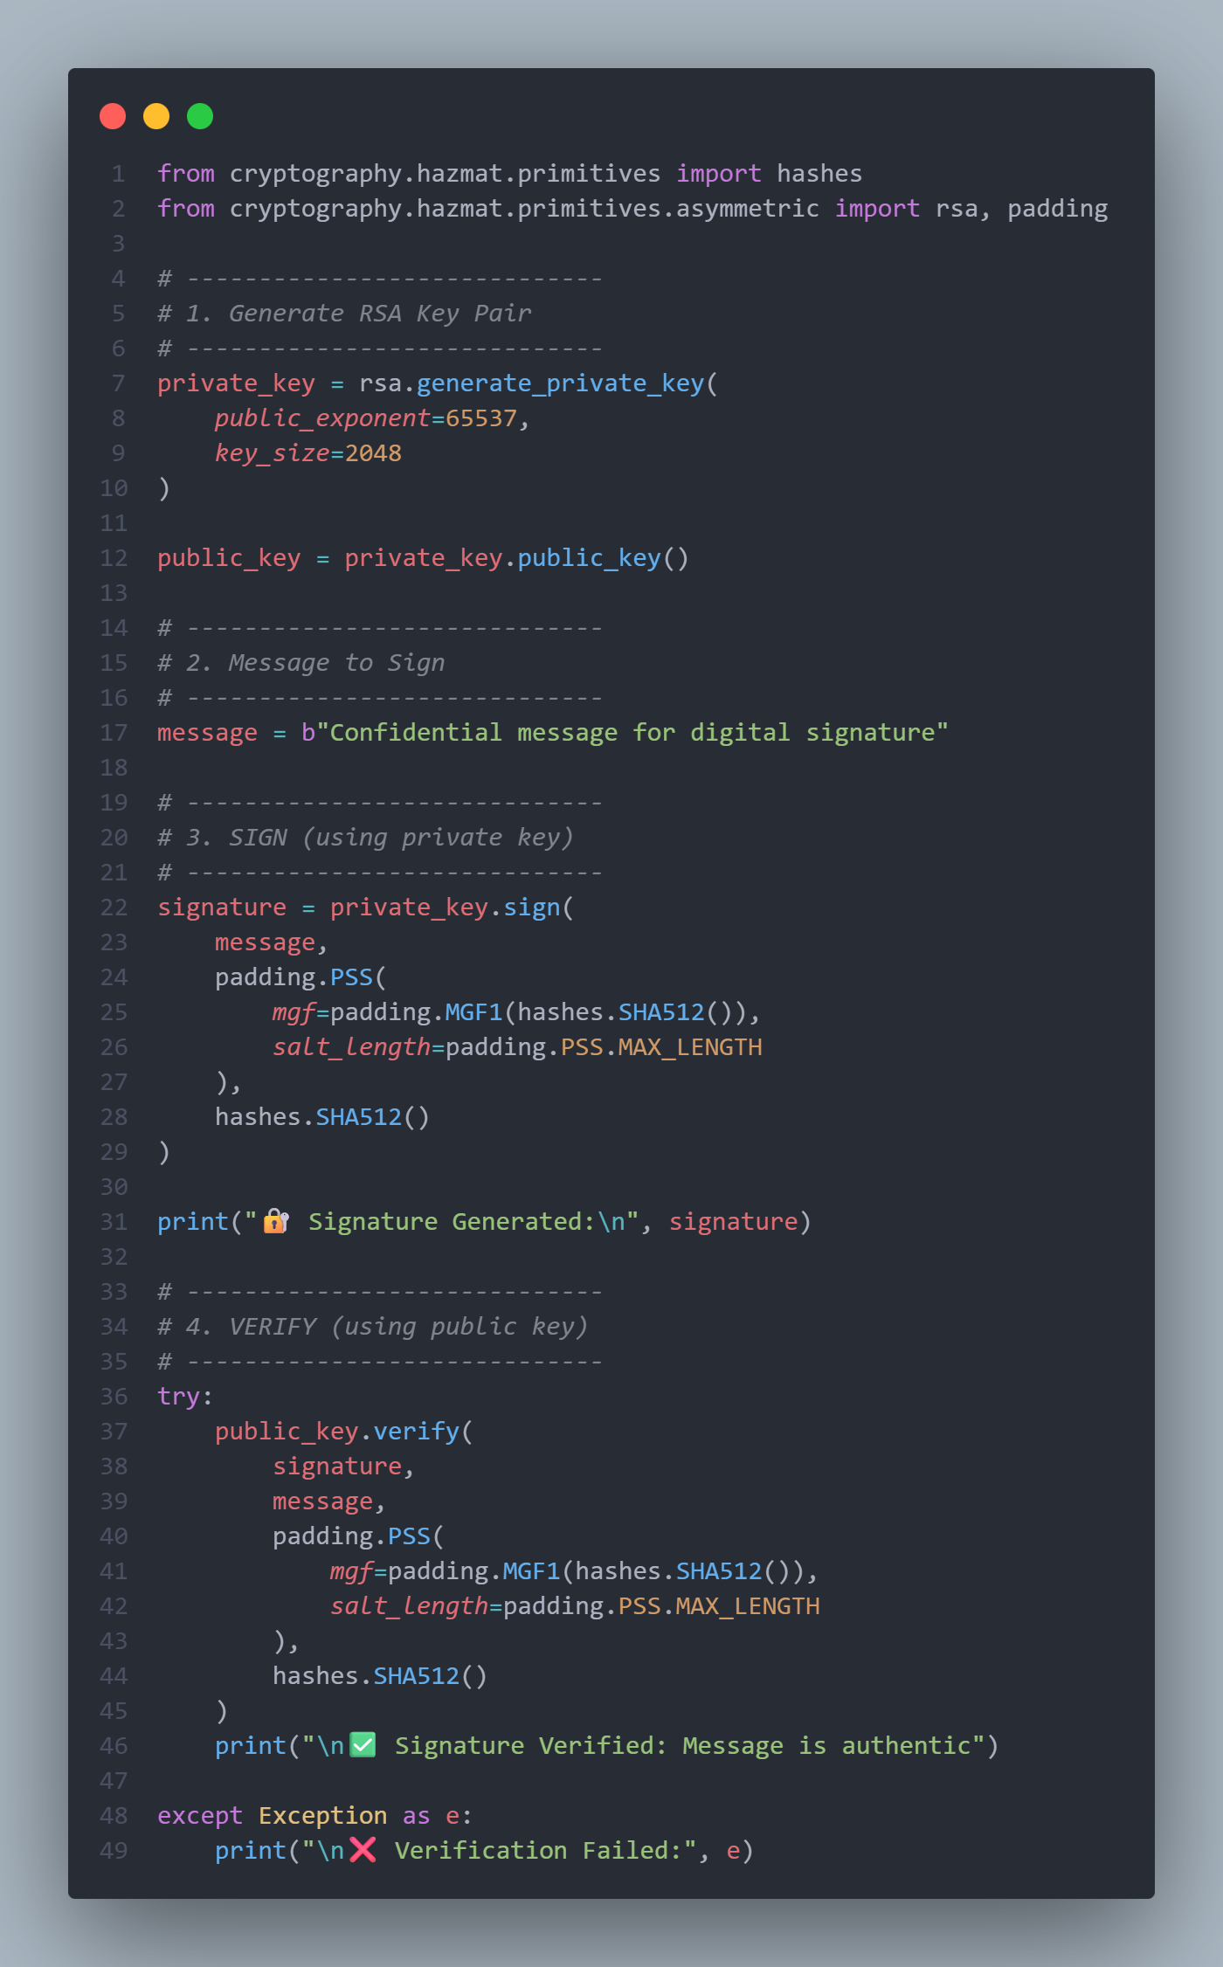

Output:
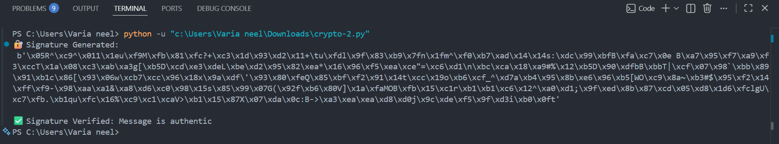

Working Flow
Step 1: Key Generation
- RSA creates:
  - Private key (secret)
  - Public key (shared)

🔹 Step 2: Signing
- Message is hashed using SHA-512
- Hash is encrypted with private key
- Output = Digital Signature

🔹 Step 3: Verification
- Receiver:
  - Uses public key to verify signature
  - Recomputes hash of message
  - Matches both

Conclusion:
This implementation demonstrates how a message can be securely signed using a private key and verified using a public key. It ensures authenticity, integrity, and non-repudiation, making it a core concept in modern cybersecurity systems like HTTPS, blockchain, and secure communications.

